Nepal College of Information Technology
Assessment
Fall 2010
Program: ELX/CE/IT Time: 3 hrs
Semester: Fall (I) FM: 100
Subject: Basic Electrical Engineering PM: 50
Candidates are required to give their answers in their own words as far as practicable.
Attempt all the questions:
1 a) Calculate the loop currents of the following network. 7
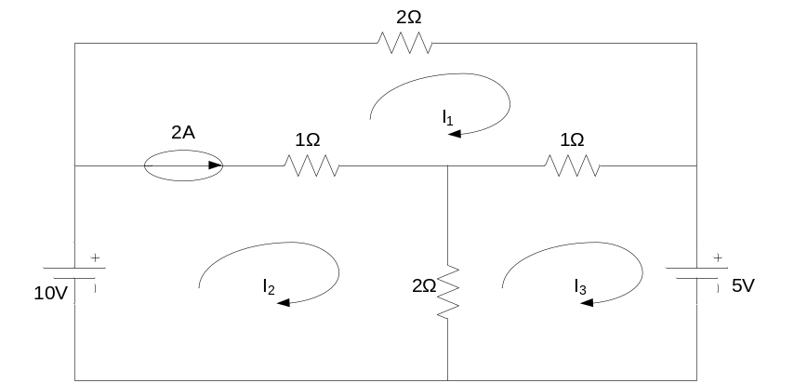
b) State and explain KCL. Find equivalent resistance between points P and Q by using star-delta transformation. 8
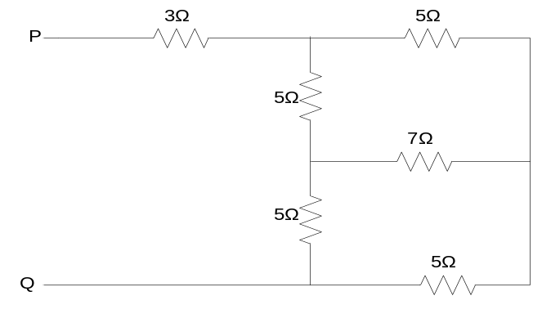
2. a) Calculate the current through 10Ω resistor of the given network using Thevenin’s theorem. 7
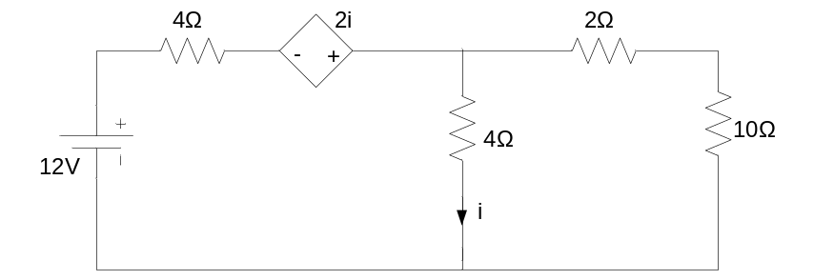
b) Find the maximum power consumed by load resistor in the circuit shown below. 8
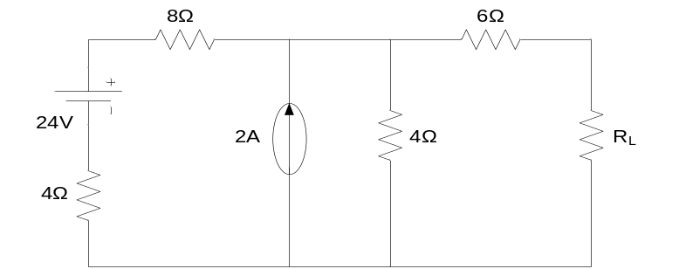
3. a) Find the average and RMS value of the following waveform. 7
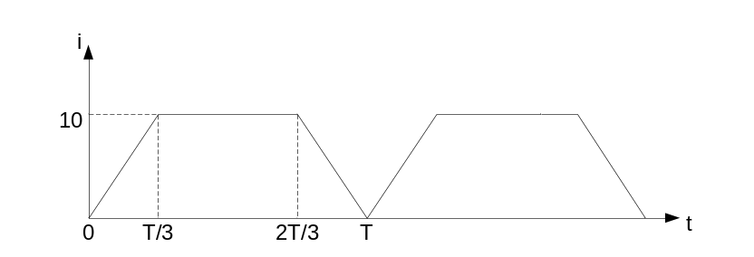
b) An inductive coil having impedance Z = 10<30⁰Ω is connected across 200V, 50 Hz source. Calculate the current, active power, reactive power and power factor. Draw the phasor diagram. 8
4. a) A ∆-connected balanced 3-phase load is supplied from a 3 –phase 400V supply. The line current is 20A and the power taken by the load is 10 KW. Find
i) Impedance in each branch
ii) The line current, power factor and power consumed if the same load is connected in star. 8
b) Explain the measurement of 3 phase power by two wattmeter method. 7
5. a) A 5 KVA, 200/440V , 50 Hz single phase transformer gave the following test results:

O.C. Test ( HV side open): | 220V | 1.3A | 120W
S.C. Test (LV side short): | 22V | 33A | 200W
Find the parameters of equivalent circuit as referred to HV side. 8
b) Derive the condition for maximum efficiency of a single phase transformer. 7
6. a) Explain the construction of DC motor. 7
b) A 200V shunt motor runs at 1450 rpm of full load with an armature current of 11A. The total resistance of the armature and field coil is 0.6Ω. If the speed is to be reduced to 1000 rpm with the same armature current, calculate the value of resistance to be connected in series with the armature. 8
7. Write short notes on any two of the following: 10
a) Single phase energy-meter
b) Eddy current and hysteresis loss
c) Voltage resonance

